Issue | State | Description | Comment | ETA | Status
1 | Monitor | Date Format Confusion | Tool Tip date format change to DD-MON-YY | 17 July | Done
2 | Monitor | Red carrot due date on Gantt Planner | Will Restore flag | 17 July | Done
3 | Monitor | Preview WO popup truncation | a) Dynamically adjust pop-up size  b) Click outside pop-up to close | a) 17 July  b) Next Release | Done
4 | More info | Toolbar ellipsis displays overlapping fields | ?? |  | Pending
5 | Monitor | Output too large max 4000 records | Limit results to 4000. Update config menu to set own limit w/max of 4000 | Next Release | Pending
6 | Resolved | Future PM meaning | Hourglass icon. Gantt w/ diff color. They are future duplicate WOs not yet released. Can be overdue or placeholder for future work. | - - | Done
7 | Resolved | Pop-up WO details off screen | By design to avoid masking WO Grid details | - - | Done -By Design
8 | Resolved | Hourglass v.s. Wrench icons | Wrench = actual WO.  Hourglass = Future event.  Number above hourglass = future sequence for that PM Schedule.  Tooltip on hover for details. | - - | Done
9 | Resolved | Global Search | Obsolete and will be removed | 17 July | Done
10 | More info | Excel Export | Unable to reproduce. Want to validate in our Train environment. |  | Done
11 | Monitor | WO Grid Sorting | Will fix caret alignment | 21 July | Pending
12 | Monitor | WO Grid Sched Start Date, EVT_TARGET, Earliest Completion Date | a) Will rename fields.  b) Use Boiler plate names | ??  Future release | Pending
13 | Monitor | Date Filter Before/After and < vs <= | Will fix functionality | 21 July | Done
14 | Resolved | Column Filters = Contains and case sensitivity | Yes: Contains, not case-sensitive | - - | Done
15 | Resolved | Multiple filter use AND logic | Yes: multiple columns use “AND” operator. If OR is needed use a Dataspy | - - | Done
16 | Resolved | Does Gantt bar affect Duration? | No | - - | Done
17 | Monitor | Dataspy editor uses database column names | Update to business names | Next release | Pending
18 | Monitor | Popup carries over to other EAM screens | Not consistent behavior. Will fix | Future release | Done
19 | Monitor | Modify holidays | Will provide Admins with access | Next release | Pending
20 | Monitor | Screen Cache | Not available. But will create a Save Filters button | November release  Agreed to provide save filter option | Pending
21 | Resolved | WO Details adjust fields displayed | No way to change | - - | Done
22 | Resolved | Day view Gantt Column numbers | Number is estimated hours for that day for WO shown | - - | Done
23 | More info | Clicking date in column title shows Day View for prior day | Not currently reproduceable | Not an Issue | More info
24 | Monitor | Review Pending Changes days counter off by 1 | Will fix | 17 Jul | Done
25 | Monitor | Quick Update to dates not reflected in Grid/Details | Will fix  Workaround: Click Refresh | Next release | Pending
26 | New | Past WO not showing w/ past From date |  | Not an Issue | Done
27 | New | Configuration changes not saved across sessions |  |  | Pending
28 | New | Future Work iterations counter limit |  |  | Done
29 | New | WO Daily List / Hours not accurate |  | Not an Issue | More info
30 | New | Toolbar Organization filter only matches on ORG description |  |  | Done

1. ‎Date format confusion.
When hovering over a work order, the popup shows a date of 06-09-2026. I'm not sure if this is June 9th or Sept 6th.
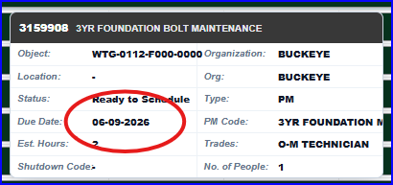
When hyperlinking to the work order, it shows a different format:
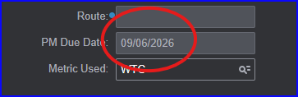
EAM WO leads me to believe it's Sept 6th.
Layout Configuration shows Date Label format of Day + Short Month with the caveat that it's only for Day Scale (column titles)
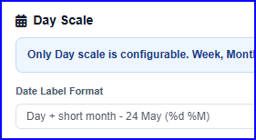

This might affect column sorting.

Request: Can we get the date format consistent with EAM, or make the format more clear like DD-MON-YY so there is no confusion?
Response:
- We will update the date format in the tooltip to DD-MON-YY, ETA: 17-Jul-26.
- Yes, the Layout Configuration shows that the Date Label format applies only to the Day Scale (column titles).


Solution:
Now Date Displayed in Gantt Screen is a configurable entity under ui Experience Section:
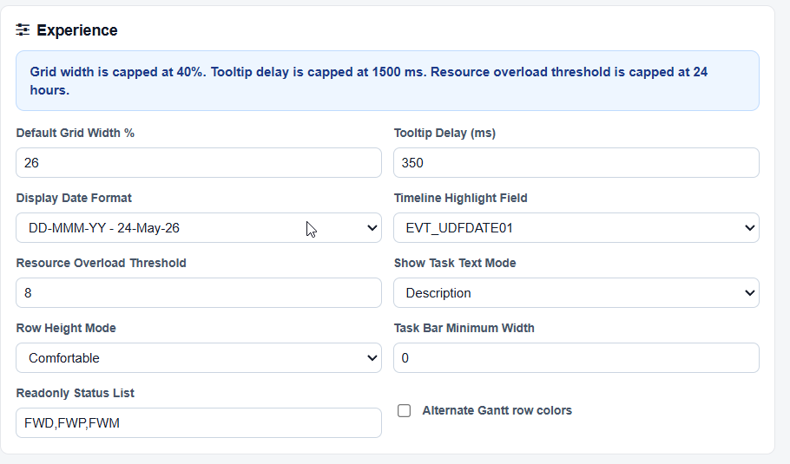

2. ‎Red carrot marking work order due date is missing from Gantt planner.
In our previous version of the software, we had a small red triangle displayed within the Gantt that marked the Due Date of the Work Order. It's visually missing.
On the Configuration dialog, marking Show Due Date Flag displays a red flag next to the work order text:
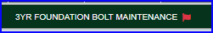
In the System Legend (i button) the last entry says
I'm missing where the due date is marked on the Gantt planner. The red flag is always next to the description and doesn't denote the date of when the work order is due.
Update: With the red flag showing, hovering over it displays the WO Due Date
Note: Functionality changed. Was this intentional?
Response:
Yes, the functionality was changed intentionally. We positioned the flag next to the Work Order description so users can quickly identify whether a Due Date exists, without having to drag along the timeline to locate the flag, especially for long-duration WOs.
Fix:
We will restore the small red triangle within the Gantt chart that marks the Work Order’s Due Date. ETA: 17-Jul-26.

3. Opening the “Preview Work Order” pop-up from a smaller screen can cause areas of the pop-up window to be off screen.
Opening “Preview Work Order” from a laptop screen causes the top of the pop-up, including the areas where you can resize or move the window and the [X] to close the window, are clipped at the top of the screen.
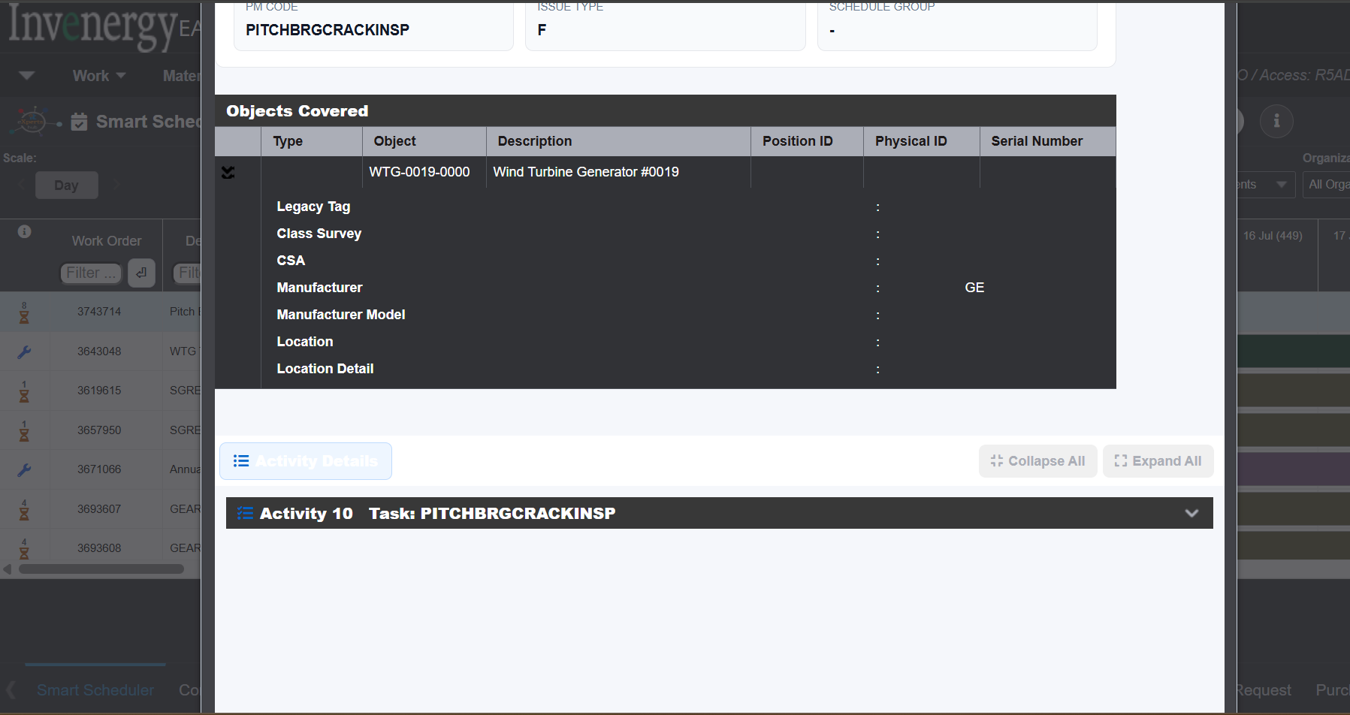
The only way to get this window to close is to press the ESC key. Recommend moving where the pop-up populates on smaller screens or allow for clicking to either side of the pop-up to the background screen causing the pop-up to close.
To Reproduce: Select a work order that is a Future PM, right click and select Preview Work Order.
Update: This issue occurs on large desktop monitors. Behavior is being driven by size of the browser window, not the monitor.

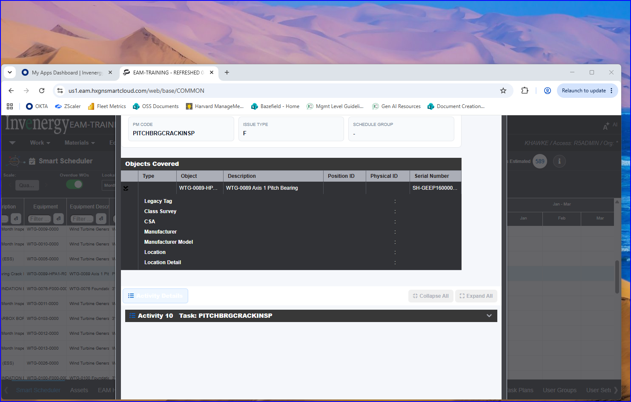
Adjusting the size of the browser window doesn’t reveal the top of the pop-up dialog, but will show the bottom:
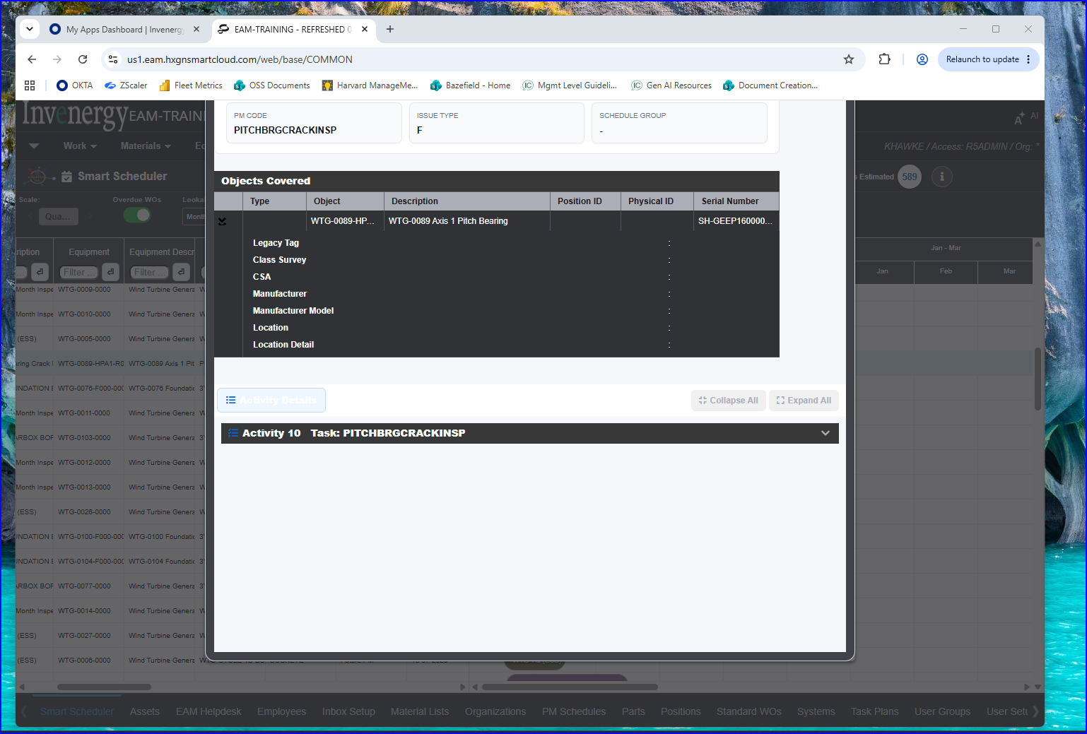
Workaround: Using escape to get out of the pop-up, instead of being able to click the “X” in the upper right corner.
Response:
Yes, pressing Escape (Esc key) will close the pop-up, and we understand your concern regarding the pop-up closing behavior on smaller displays.
Fix:
We will retain the [X] close button at the top by dynamically adjusting the pop-up size based on the screen resolution so it fits properly on smaller displays. ETA:17-Jul-26.
Next release: Additionally, we will incorporate click-outside-to-close, where clicking anywhere outside the pop-up (on the background screen) will close it.

4. Toolbar ellipsis displays overlapping fields
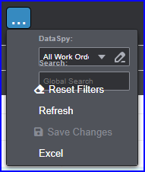
The overlapping fields make it difficult to click on the items.
Appears to only be visual display issue.
Q: What makes the ellipsis appear, rather than the actual tool bar buttons? Expanding the screen doesn’t make it go away. I think I had to re-launch the screen.
Response:
Yes, this is only a visual display issue. When we attempted to reproduce it, the issue occurred at higher browser zoom levels, where some toolbar buttons do not render correctly.
All toolbar buttons appear as expected at 90-100% zoom, and the screen may require a re-launch for proper alignment. We would still like to validate this once more directly in your system to ensure everything is working as expected.

5. Refresh button throws error: Output value too large (maximum: 4000)
- Screen filter is set to Buckeye
- Scale is Quarter
- Overdue Wos marked
- Clicked the refresh button to get more rows to display because the bottom of the screen is blank after resizing browser
Note: Resizing window left and right causes a refresh, but resizing vertically does not. You can maximize the browser window, then minimize. When you maximize the window again, part of the screen is blank.
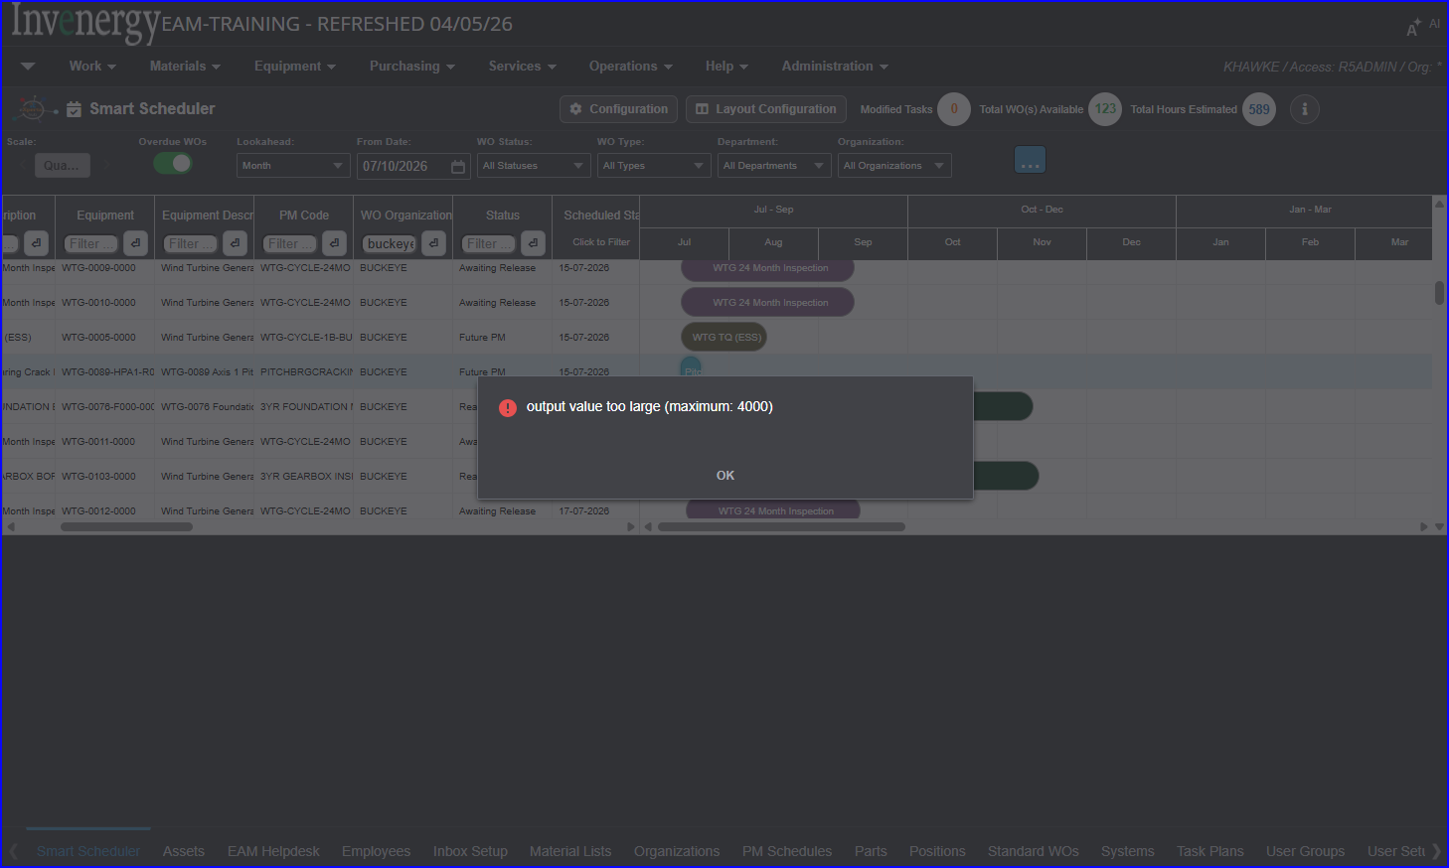
Need to document cause of error and how to resolve.
Note: Unmarking Overdue WOs, and clicking Refresh again, appears to eliminate the error. Rows filled to bottom of the screen.
Response:
Yes, The Overdue WOs filter restricts the output to 4000 records. Screen retains the previous results.
Next release: We will limit and load the results upto 4000 records. we will update the configuration menu so that you can set your own record limit. (max limit set to 4000)

6. What does a status of “Future PM” mean?
The actual WO status is Ready to Schedule.
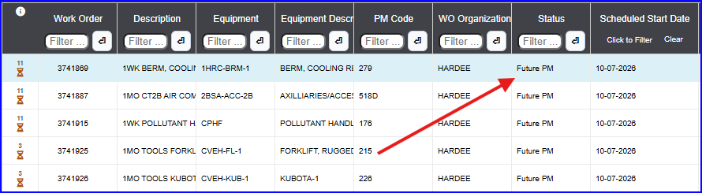
Right clicking the WO show menu item “Preview Work Order”
But searching the WO screen shows a status of Ready to Schedule
These WOs all have the hourglass icon
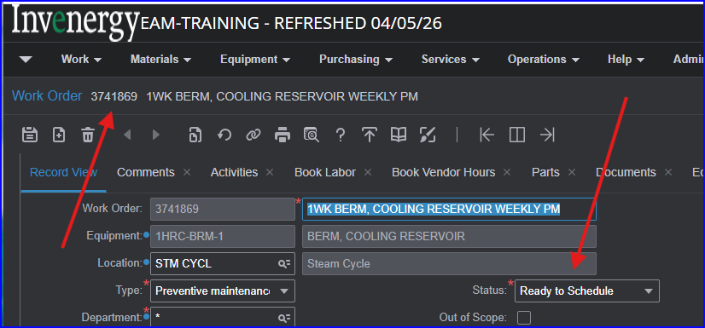

Response:
The Work Order 3741869 with status “Ready to Schedule” is an actual WO and can be viewed directly in the WO screen. The Future PMs (shown with the hourglass icon and same WO number) are future duplicate Work Orders. They appear on the Gantt timeline as per PM schedule frequency appear in a different color, and they cannot be viewed in the WO screen.
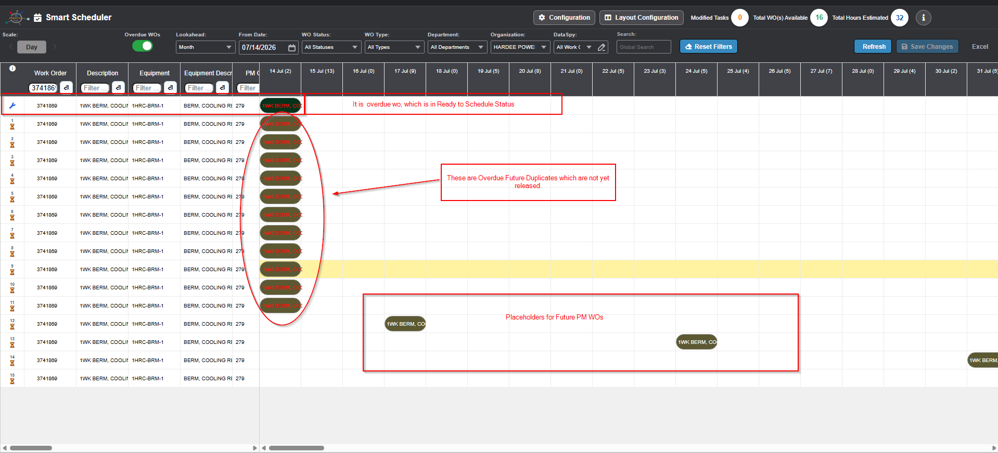

7. Pop up WO Details off screen.
Hovering over WO Grid causes popup to display in Gantt area. Appears to be bound by dividing line between the 2 screen sections.
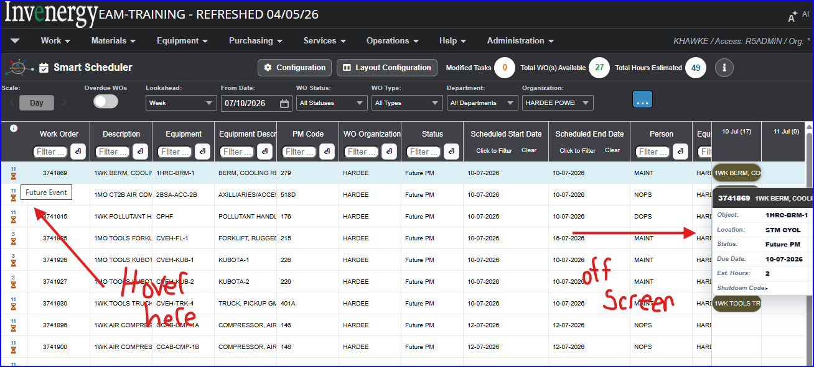
Hovering in Gantt area causes popup to dynamically view:
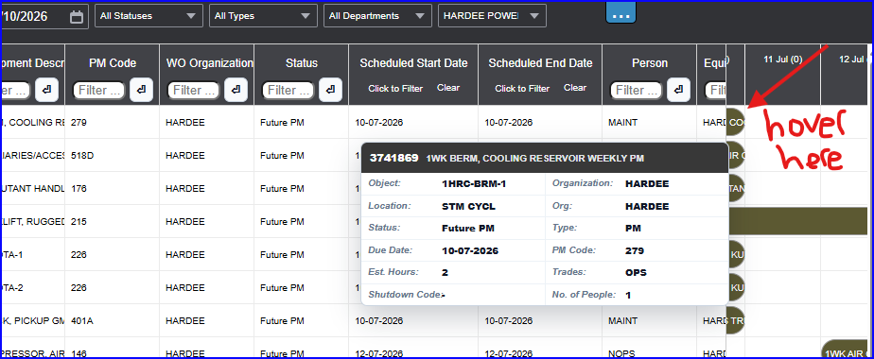

Response:
Yes, this is by design, the tooltip pop-up appears only on the Gantt area. If it were displayed on the WO grid area, it would overlap or hide the details of the Work Order.
If needed, we can make the tooltip appear within the WO grid section as well along at the mouse-pointer location. Please let us know.

8. Hourglass & number vs Wrench icon
What causes the hourglass to display and what are the numbers above it? What is the difference between that and the Wrench icon.
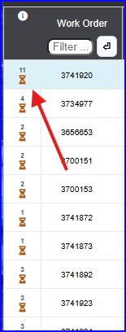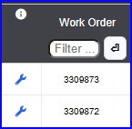
Response:
The wrench icon represents the actual Work Order, and the hourglass icon indicates a Future Event and the number is its future sequence as per the PM Schedule. A tooltip also appears when the mouse pointer hovers over these icons to display additional details. We will add this to the legend also. ETA:17-Jul-26.

9. Search command
Unpredictable functionality. What fields are searched? It’s listed as a global search but results are not predictable.
In the below screen capture, grid columns are filtered to the ORG Golden Plains and status of Awaiting Release. Several WO descriptions show WTG Torque.
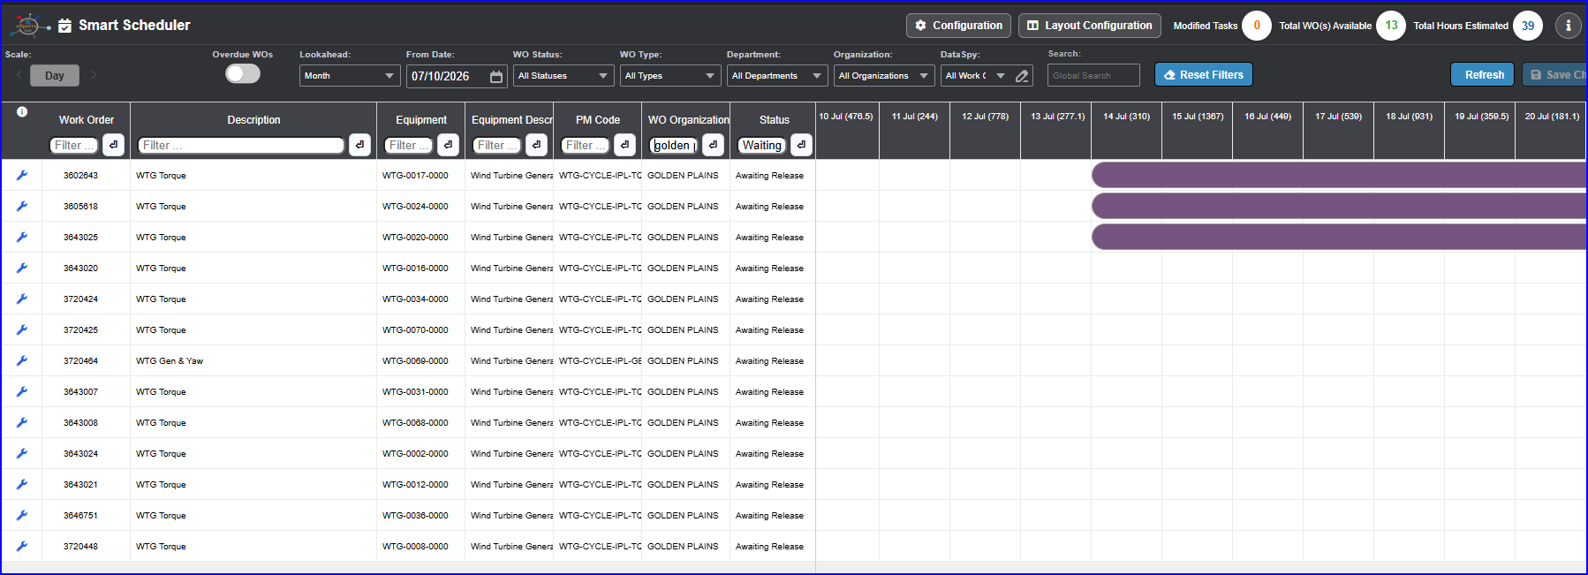
Entered Torque in the Search and clicked Refresh to make it active. (pressing enter doesn’t make it active)
No records display, but WO available shows 5534
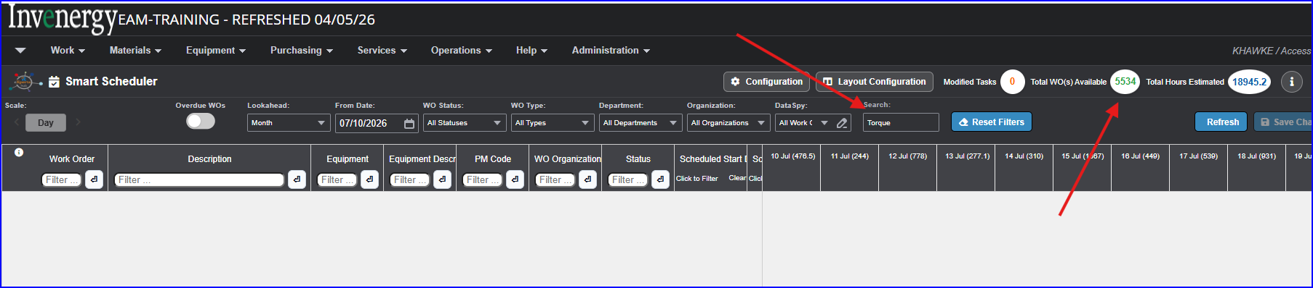
Response:
Yes, this ‘Global Search’ is obsolete and causes delays when loading filtered content. It was originally used before column-level search filters were introduced.
Fix:
We will remove the global search from the toolbar to free up space for other required toolbar components. ETA: 17-Jul-26.
Note: If there is a demand for Global Search, we may include fully functioning feature in future release.

10. Excel export Internal Server error
Filtered WO Grid to 13 records:
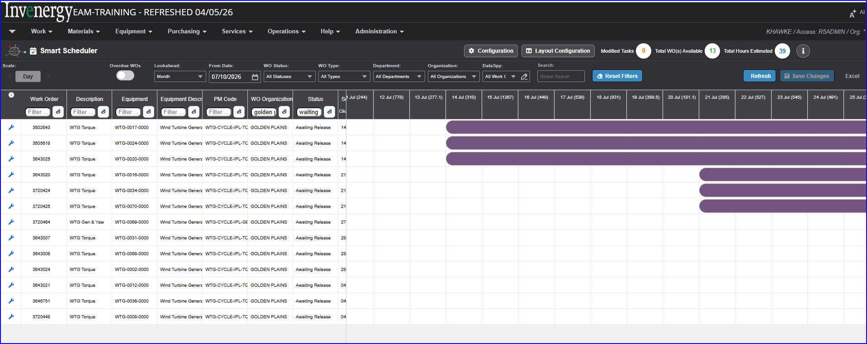
Clicked the Excel link, unblocked the Pop-up, a new browser tab launched, and a timeout error was displayed after a few seconds:
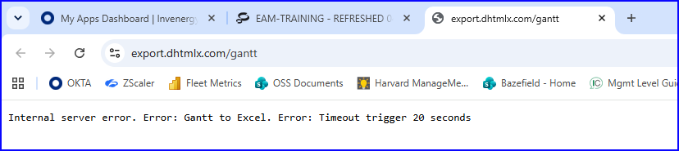
Different error on exporting 21 records: Request entity too large
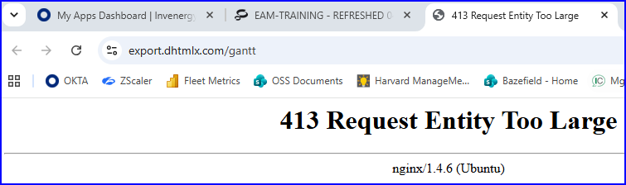
Response:
We tested this in your environment and were able to download the Excel report successfully. We would like to validate it once more directly in your system to ensure everything is working as expected.

11. WO Grid column sorting not same functionality as EAM
Looking for consistent behavior with EAM.
In EAM, the upward pointing sort caret denotes oldest WO first, or lowest WO # first, or ascending values lowest to highest.
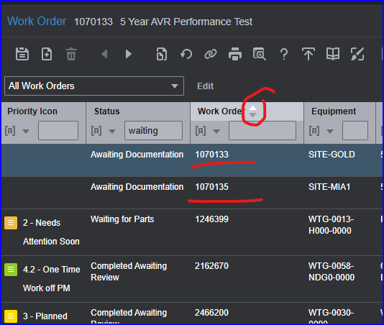
Smart Scheduler upward caret is doing a descending sort.
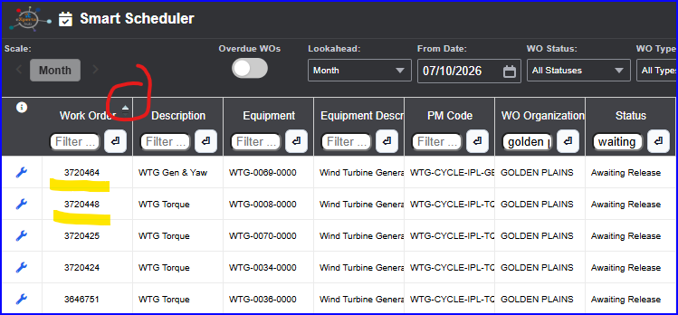
EAM Descending WO # sort (downward caret)
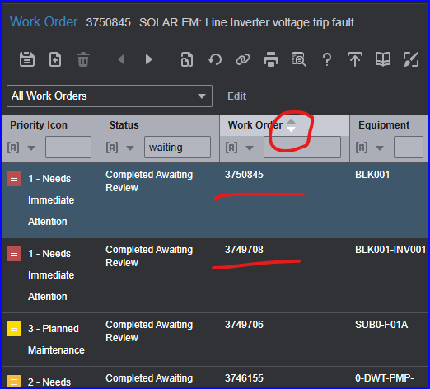
Downward caret is showing ascending WO numbers in Smart Sheet.
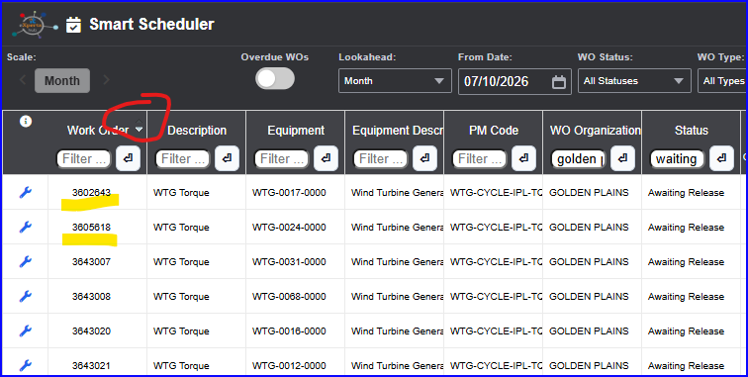
Response:
This is a great observation. Thanks for bringing to our notice. We validated the sorting behavior but did not check the caret position.
Fix:
We will correct the caret alignment and make it behave consistently as EAM-style sorting. ETA: 21-Jul-26

12. WO Grid: Scheduled Start Date
Is the Scheduled Start Date evt_target? In our system, it’s called Earliest Completion Date.
Q: Can the field text be pulled from boilerplate since we renamed it? This would cause less confusion for users.
Response:
Yes, the Scheduled Start Date corresponds to evt_target. We will rename the fields as per your choice.
Note: Pulling the label names from Boiler text will be in future release.

13. Clarify Date filter operator functionality Before / After
Does before / after operators include the provided date? i.e the difference between > and >=
Response:
This is a great observation. Thanks for bringing to our notice. We observed that the date filters are not working as expected.
Fix:
We will correct the date-filter functionality to ensure it works effectively. ETA: 21-Jul-26.

14. Clarify column filters are all “contains” operators
Also that they are not case sensitive (they don’t appear to be).
How do you filter out work order status of “Future PM”
Response:
Yes, column filters are not case-sensitive and operate using a “contains” logic. Also, there is no Work Order status called “Future PM”; it is only an indicator, not an actual status. Future PMs can be filtered using column filters.

15. Clarify that when multiple column filters and toolbar filters are specified, they are “AND” conditions
Assuming “OR” condition is specified by editing the data spy.
Response:
Yes, both the column filters and toolbar filters are applied as “AND” conditions. “OR” conditions can be configured only by editing the DataSpy.

16.Does adjusting Gantt bar length affect Work Order duration?
Or just the start/end dates of that WO?
Response:
No, we observed that you are storing the Duration in a User-Defined Field (EVT_UDFCHAR07). Adjusting the Gantt bar length will not affect this custom duration logic.
If you would like the duration (EVT_UDFCHAR07) to change based on the Gantt bar adjustment, we can work on modifying it accordingly.

20- July:
We need a call with customer to understand the current business process.

17. Dataspy editor uses database columns instead of business names.
Can this be changed? Users will not be able to match up the technical names.
Response:
Yes, the DataSpy editor uses database columns. We can change this behavior, and we will incorporate the update in the next release.

18. Popup from Smart Scheduler carried over to other screens
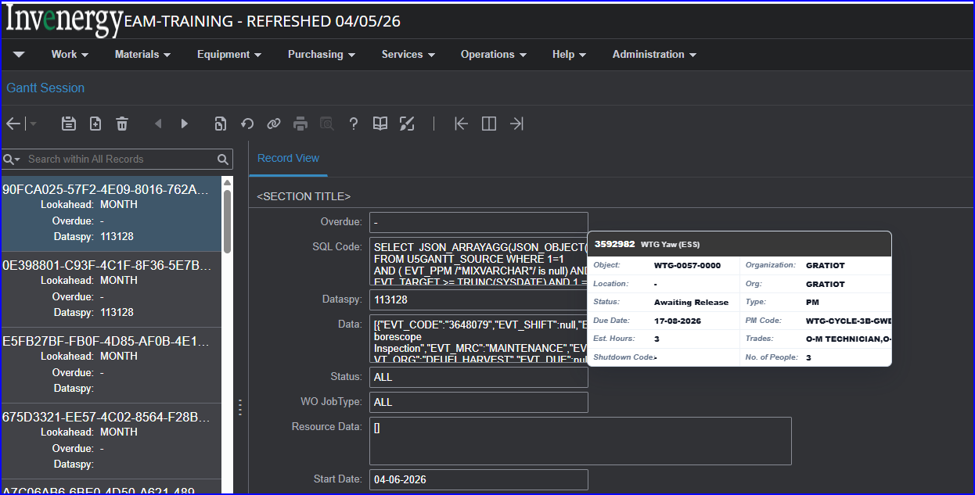
The popup was active when I navigated to Work > Smart Scheduler > Gantt Session.
Note: Unable to remove from Gantt Session screen, but it went away when I navigated back to the scheduler.
Response:
We will investigate it and observe the behavior to fix the issue. We are able to reproduce this issue only when switching to another screen using Ctrl+F2. This is not occurring consistently, and we will fix this issue.

20 July:
The issue is resolved now.

19. How do we modify holidays?
Layout Configuration says SYADAV (Sai Ashok Yadav) and ADMINUSER1 can change. Who is AdminUser1 (can’t find)?
Can this be changed to just the R5ADMIN User Group rather than user-specific?
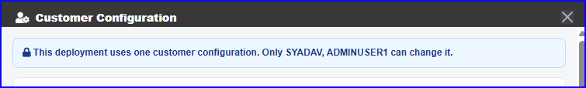
Update: I see a note in the documentation to contact the Implementation consultant to have the admin functions made available within “Admin” module of EAM.
Response:
Yes, we will provide the admin functions to specific users as per your request.

20. Can the smart scheduler be added to screen cache?
Or have a way to save settings when you navigate away from the screen to not lose the filters.
Response:
Unfortunately, it cannot be added to Screen Cache.
Yes, we understand that you want to reuse the applied filters.
Fix:
We will provide a ‘Save Filters’ button that allows you to save the currently applied filters. After applying the required filters, clicking ‘Save Filters’ will store them as a reusable set, which can also be applied on your next visit. ETA: Next release in November 2026.
.

21. Work Order Details: Can we adjust fields displayed?
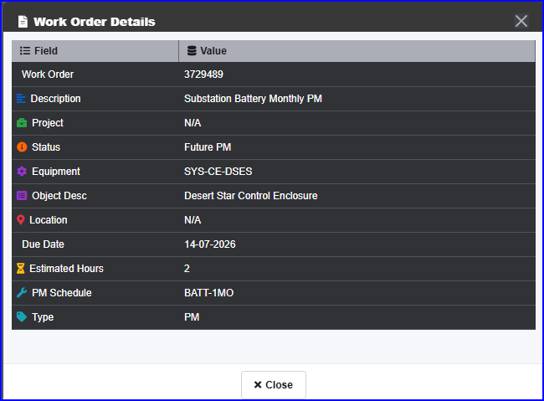
Response:
No, the fields displayed on this pop-up cannot be adjusted by the user. If you want the fields to appear in a different order or need more fields, we can arrange that for you.

22. Day View Gantt Column Titles show unknown number in parentheses.
What is the number?
Response:
The number shown in parentheses represents the Estimated Hours for that day for all the WOs scheduled on that day. When you click on it, a pop-up window opens and displays the list of Work Orders scheduled for that day, along with the Estimated Hours for each Work Order.

23. Clicking Column Date shows Day View for different date
Clicking July 20th column title shows July 19th in dialog box
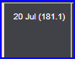
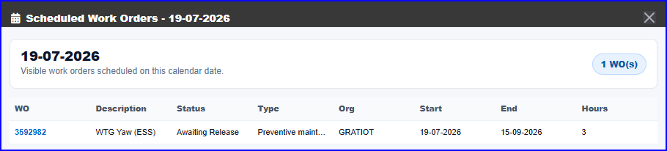
Response:
It is not reproducible on our end in your environment. The system correctly shows the Day View for the same date that was clicked. We will further investigate and get back to you.

24. Reviewing WO date changes – counter 1 day off
A work order start date was changed from the 15th to the 14th of July. When saving change, the summary dialog box shows 3 days.
I suspect the new schedule is 1 day off. It should say 2 days with +1 day.
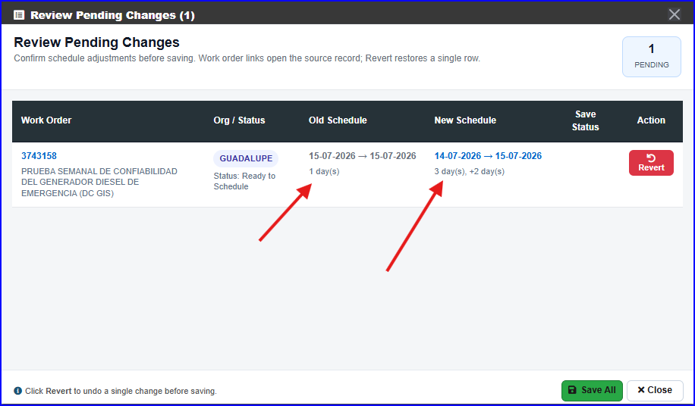
Response:
We observed this issue, and the current logic is displaying incorrect information.
Fix:
We will correct the logic so that the system displays the accurate information as expected. ETA: 17-Jul-26.

Its resolved in local environment.

25. Quick Update changes Gantt bar, but leaves WO Grid, and Day Report at original values.
Right click the WO and select Quick Update
Change the start, end and Assigned TO. Save Changes.
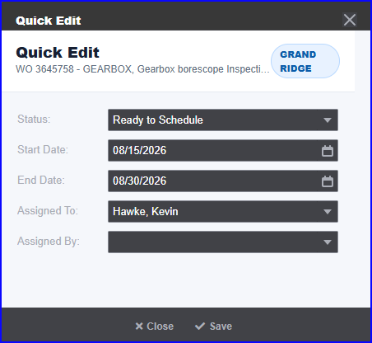
1st Problem: Gantt bar moves, but WO Grid dates reflect old values. Day report dates reflect old values.
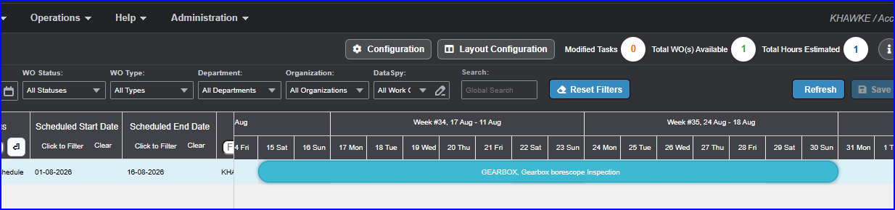
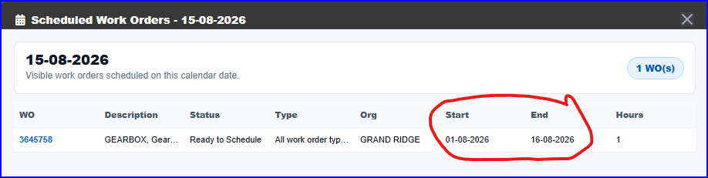
Hyperlink to WO shows updated values. Performing a 2nd Quick Update shows correct values.
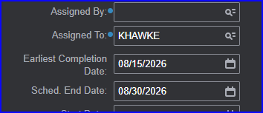
2nd Problem:
Clicking the Refresh button, and searching for the WO # returns no results:
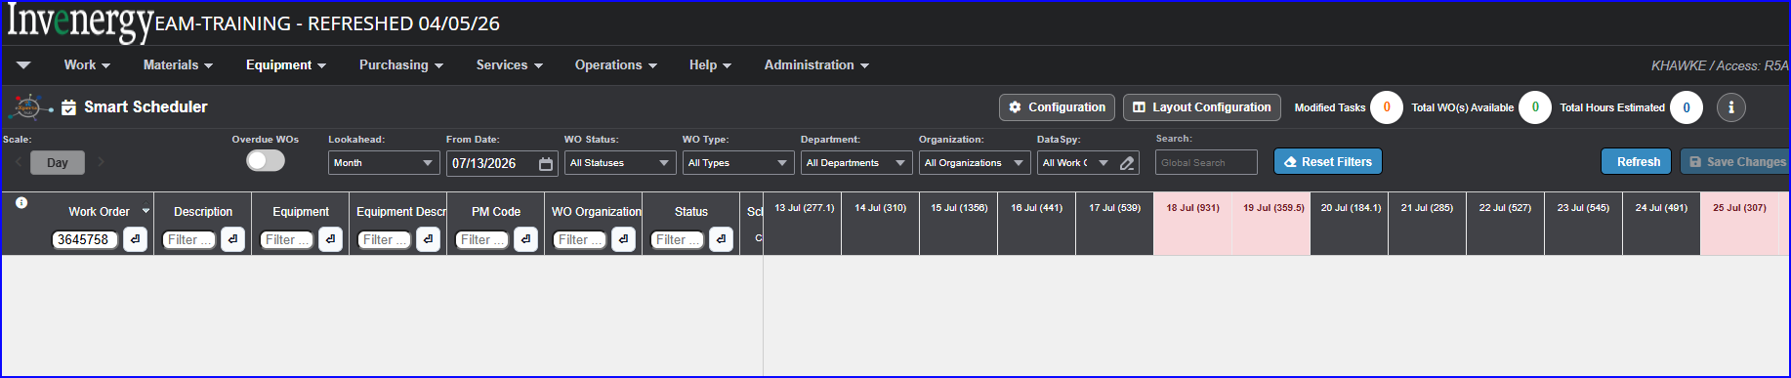
This may be caused by the date mis-match between the WO Grid and the WO.
Response - 1st Problem:
After making single or multiple changes, clicking the Refresh button will update the WO grid and the Day View pop-up with the new dates.
Note: We will fix this in the next release.
Response - 2nd Problem:
Yes, you are correct, the Work Order did not appear because its dates fall outside the selected range.

26. Past WO not showing w/ past From date
Overdue WO 3718363 is active with a start date of 3/3/26 and a status of Ready to Schedule
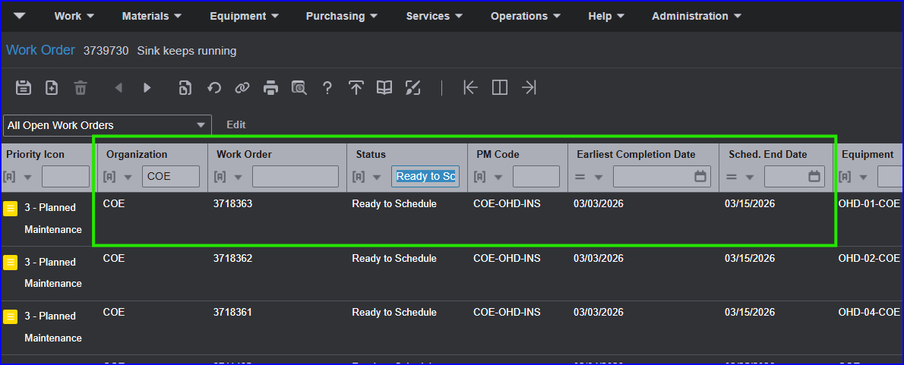
In the scheduler, with a From Date of 3/1/26, Lookahead of Month, and a column header filter to WO 3718363, Icon is Hourglass (6), scheduler shows status as Future PM with dates in August:
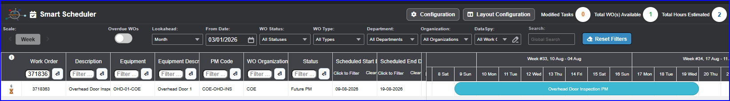
The active work order is missing even though the From Date is before the WO start date.
Mark Overdue WOs and refresh (add filters to get past the 4000 row limit error).
Possible issue: The Gantt Planner does not start at the From Date value, but remained at the location prior to activating the Overdue WOs switch.
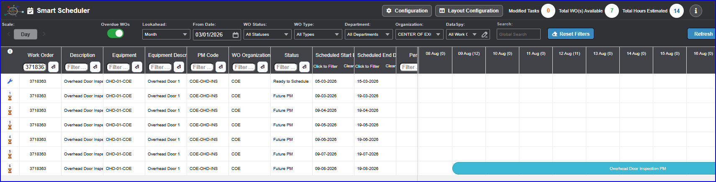
Active work order shows with 6 future iterations.
Possible Issue: Setting the From Date to a past date did not bring in the overdue WO, which was expected.
Response:
Yes, this is by design. When the From Date is set to a past date, past Work Orders will not appear if the Overdue WOs toggle is turned off..

27. Configuration changes not saved across sessions
Changes to the configuration dialog are preserved until you log out of EAM.
With the proposal of saving filters, also save configuration settings.
Response: Since this is a toggle button, the user can turn it on or off as needed.
Option 1: We can set the requested buttons to ON by default.
Option 2: We will explore the possibility of preserving the configuration dialog, as requested, at the time of delivering the Save Filters functionality.

28. Future Work iterations counter limit
Future work displays an hourglass icon with a number above it. The number identified the iteration of the schedule. Clarification is needed on how far out the counter will go. Maximum counters seen are 6, and 11. What’s the determination of how far out it will go?
Response: The determining factor here is the Lookahead filter on the toolbar. Increasing the Lookahead value will allow you to see more Work Orders based on their schedule.

29. WO Daily List / Hours not accurate
Filtered down to a single overdue work order – also showing 6 future iterations.
In the Colmn titles of the Gantt planner, the numbers in parentheses are not matching what is shown on the screen.
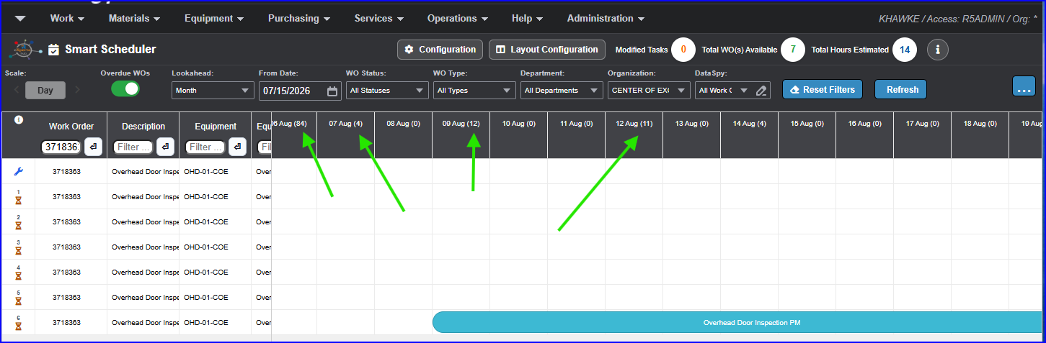
Clicking on the 12 Aug (11) column title to get a list of Daily WO produces this report for 11 Aug showing 2 hours and 1 work order:
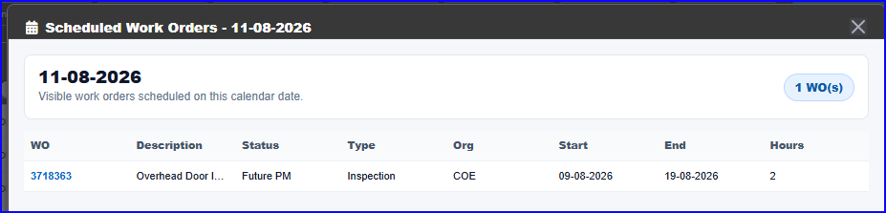
Clicking on the 13 Aug (0) date shows the following report:
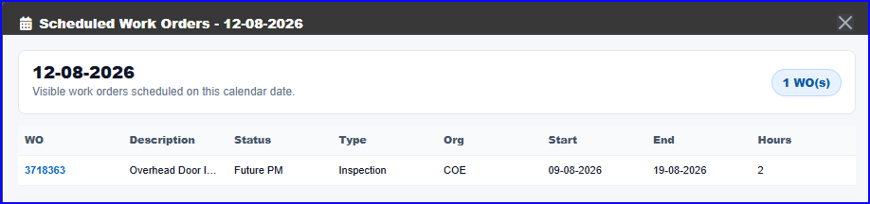
Clicking on 06 Aug (84) which will show 05 Aug (107):
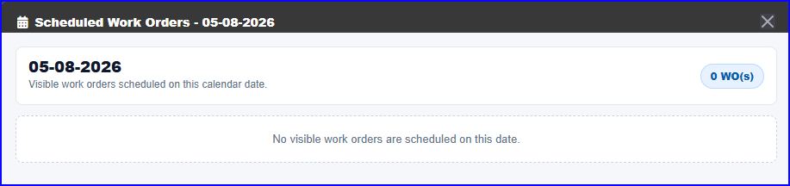
Response:

We tested this in your environment and were able to see the correct WO list of clicked dates, and correct hours. We would like to validate it once more directly in your system to ensure everything is functioning as expected.

Looks like this is by Design.
- The Value in the brackets indicates, Total number of hours on work orders starting on specific day
- The Popup Indicates list of work orders are progressing on a given day (Some of them might start in the past day)

30. Toolbar Organization filter only matches on ORG description
Can it also match on ORG code?
In this example, searching for Organization COE. Entering CO shows Coyote Ridge, but not COE.
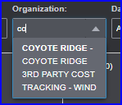
Searching for Center shows the COE entry.
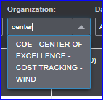
Desired functionality: Since both the code and description are displayed in the drop down, being able to search on either entry to obtain a match is best.
Response:
This enhancement would need to be implemented for other filters as well, if required. If you are comfortable with this approach, we will plan this update for the November release.

